Chapter 12: Nonrenewable Energy Resources

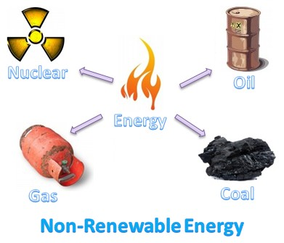

Can you….

1. Describe the use of nonrenewable energy in the world and in the United States?
2. Explain why different forms of energy are best suited for certain purposes?
3. Understand the primary ways that electricity is generated in the United States?
4. Discuss the uses of coal and its consequences?
5. Discuss the uses of petroleum and its consequences?
6. Discuss the uses of natural gas and its consequences?
7. Discuss the uses of oil sands and liquefied coal and their consequences?
8. Describe future prospects for fossil fuel use?
9. Describe how nuclear energy is used to generate electricity?
10. Discuss the advantages and disadvantages of using nuclear fuels to generate electricity?